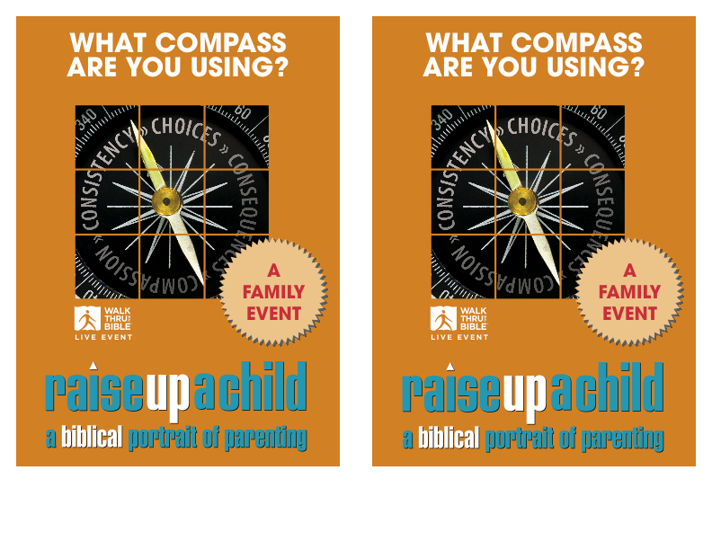
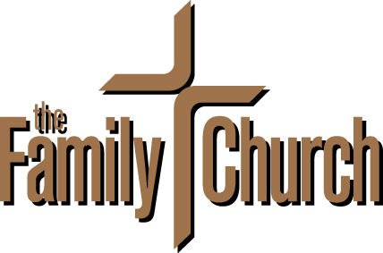
WHAT: A Biblical Portrait of Parenting LIVE EVENT
WHEN: Sunday, August 3
WHERE: The Family Church, Worship Auditorium
MORE INFO: Visit myfamilychurch.com for more information.
WHAT: A Biblical Portrait of Parenting LIVE EVENT
WHEN: Sunday, August 3
WHERE: The Family Church, Worship Auditorium
MORE INFO: Visit myfamilychurch.com for more information.
